Attention patient list of insurance our practice participates with January 2021 Year
Medicare and Railroad Medicare
Medicare Advantages Plans:
- BCBS ●Aetna ●Cigna ●Humana ●Wellcare HMO ●Careplus HMO ●Freedom Health
- Optimum HMO
- United Healthcare (UHC) Dual Complete RPPO [ group #’s 82080 and 82082] Medicare/Medicaid
- United healthcare (UHC) WELLMED Examples on back
○ WELLMED Payer ID Only accepted- Payer ID: WELM 2
United Health Care (UHC) Medicare Solutions PPO
WE ARE OUT OF NETWORK WITH ALL OTHER UHC MEDICARE AND MEDICAID PLANS. WE ARE ABLE TO TAKE THE PPO AND POS PLANS BUT THERE ARE HIGHER COPAYS, COINSURANCE, AND DEDUCTIBLES FOR PATIENTS]
Traditional Medicaid and Medicaid Plans
●Sunshine Health
● Staywell
●Coventry- Dr. Upadya, Dr. Yelamanchi, Dr. AL Aloul
Military
● Tricare Standard ● Tricare Prime –HMO ● Champ VA ●Non VA care program
Commercial Insurances
● All Blue Cross Blue Shield plans
* Please note we will accept Blue SELECT coverage and patient responsibility is 50% including higher deductible due to our practice being out of network*
● Humana- PPO, Humana HMO, Premier, Humana POS
● Aetna PPO, Aetna HMO,Aetna POS
● Cigna PPO, Cigna HMO, Cigna PO
● Care Improvement Plan-open Access
● GHI- Dr. Upadya, Dr. Al Aloul
Please be aware on the HMO plans you will need to have prior approval before an appointment is made, this includes: office visits, Diagnostic Test and procedures.
We will not be able to treat you without an approval per your insurance guidelines.
IF no approval has been received please contact your primary care physician so they can see you and treat you or please go to the closest emergency room.
The office will do our best to try helping you, but if you have any questions regarding your insurance please contact your insurance carrier or refer to your insurance book.
FLIP OVER
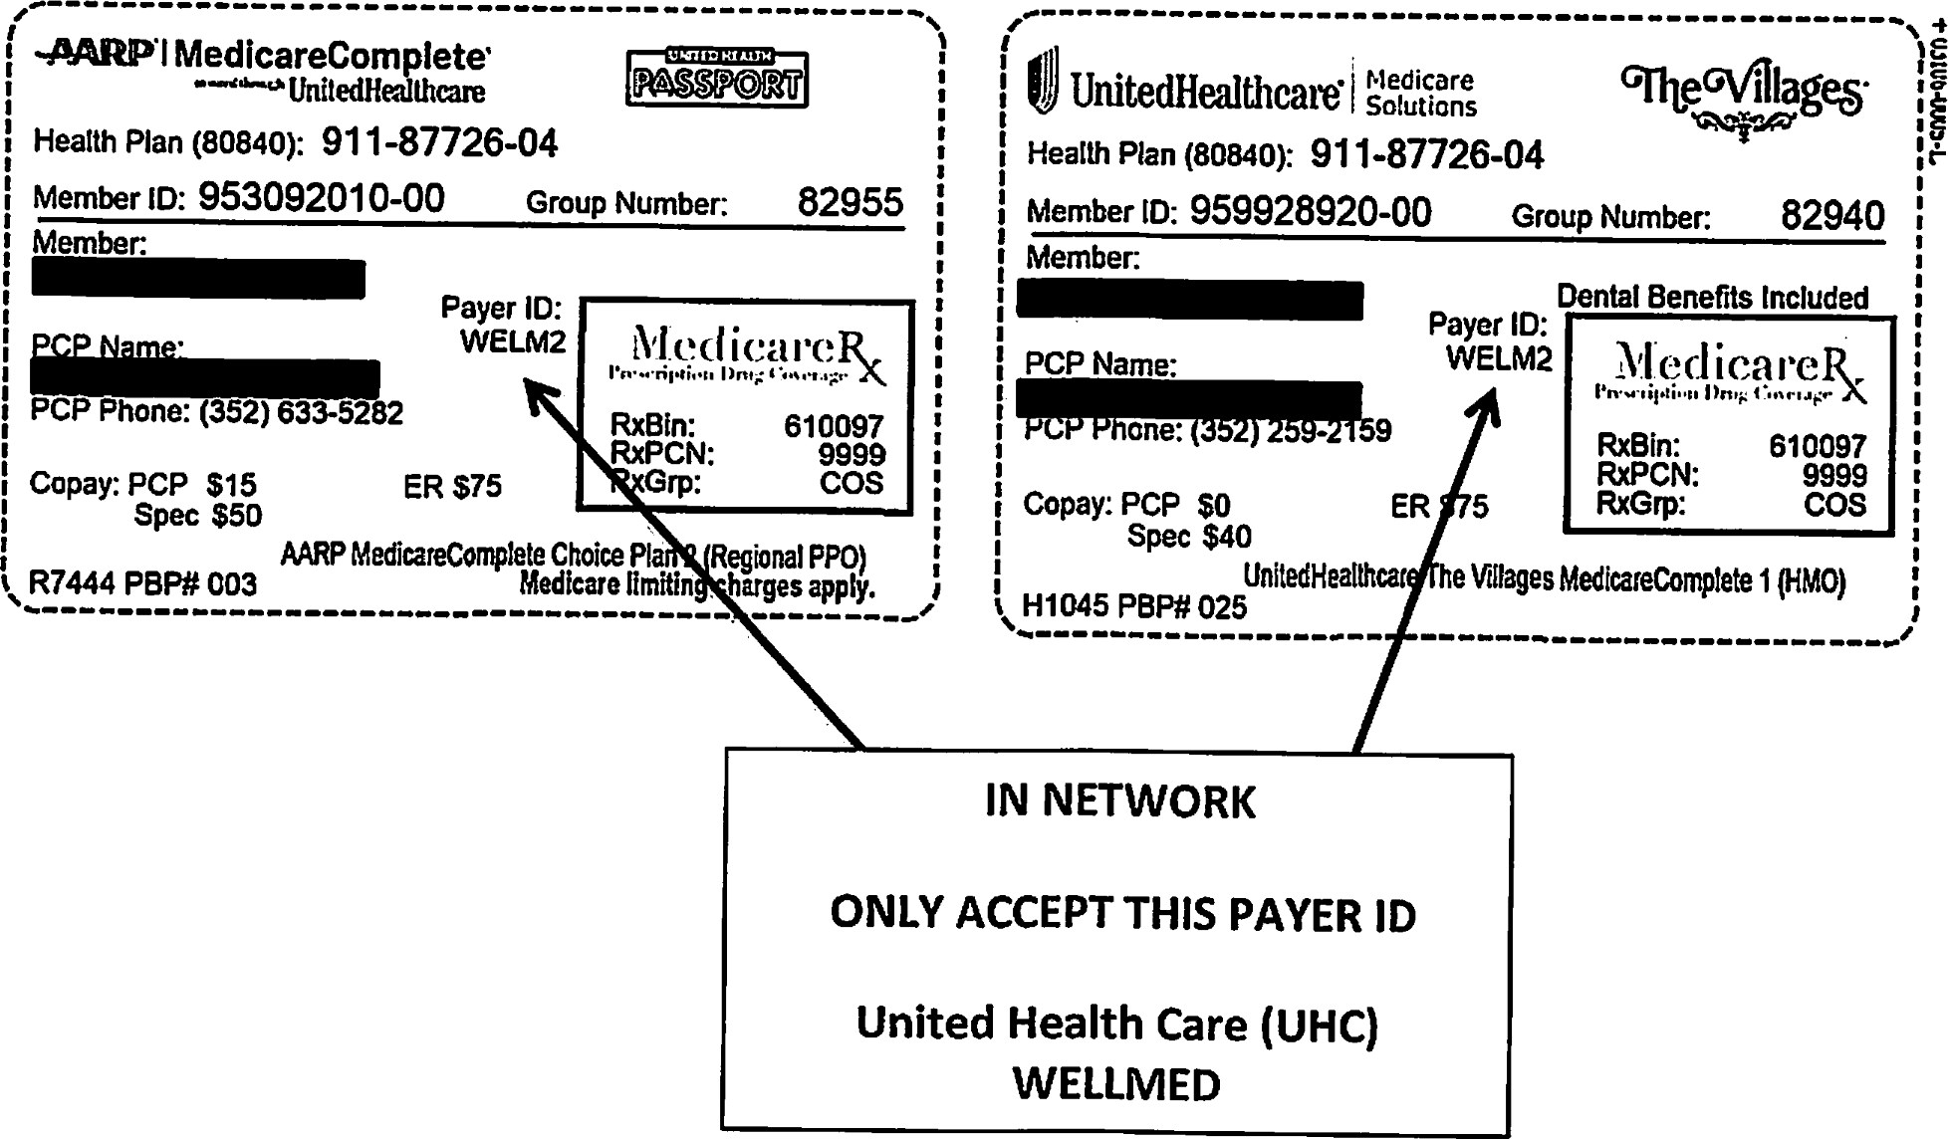

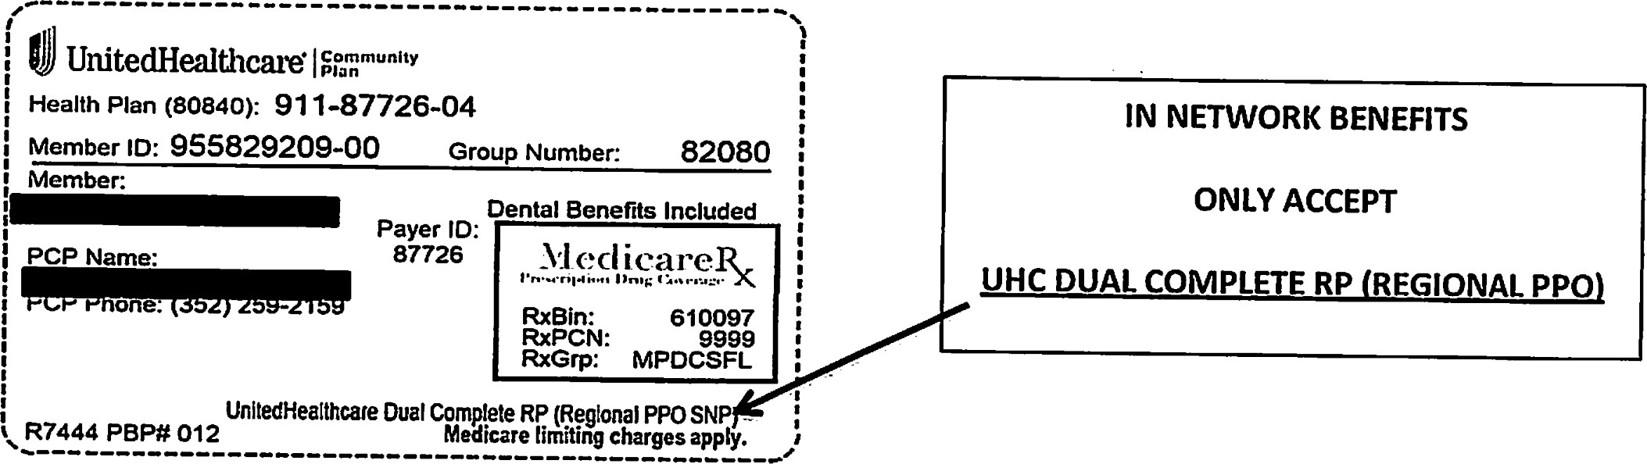

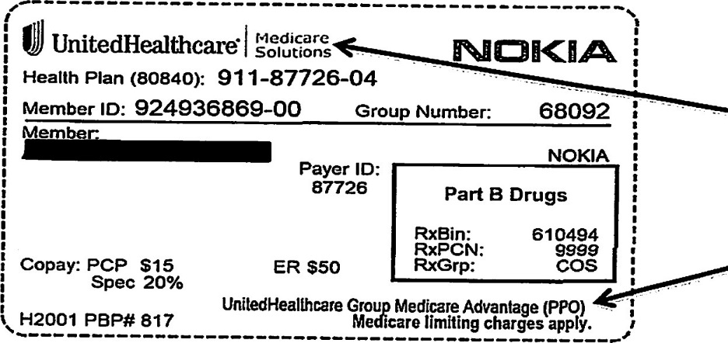
IN NETWORK BENEFITS ONLY ACCEPT UHC Medicare Solutions PPO

